The Benefits of Massage
- In general, massage offers preventative care to support your ongoing health and well-being.
- Massage has medical and rehabilitative applications, as well as health and wellness, beauty and relaxation, and even sports fitness maintenance and injury recovery. It can be beneficial as an adjunct to Chiropractic care, or simply as a way to be good to yourself.
- Massage increases circulation and promotes healing by removing waste products and bringing nutrients to your tissues.
- Massage therapy helps to resolve pain and improve mobility. You may find it easier to stretch and exercise, helping you to maintain and even improve flexibility, strength and balance.
- Massage triggers the body’s relaxation response by interrupting the cycle of stress and muscle tension that can build in response to life’s challenges.
- Massage can improve or help you maintain good posture, by releasing the muscles that might make it hard to stay in proper alignment.
- It Makes You Feel Good!!

Your Massage Therapist
Massage therapists have extensive training in a wide variety of massage techniques and modalities, anatomy and physiology, and knowledge about when massage is and is not appropriate for a person. Most professional therapists are certified by schools and/or the National Certification Board. Your therapist will gladly explain his or her specialized education, experience and certification.

This brochure was provided to you by:
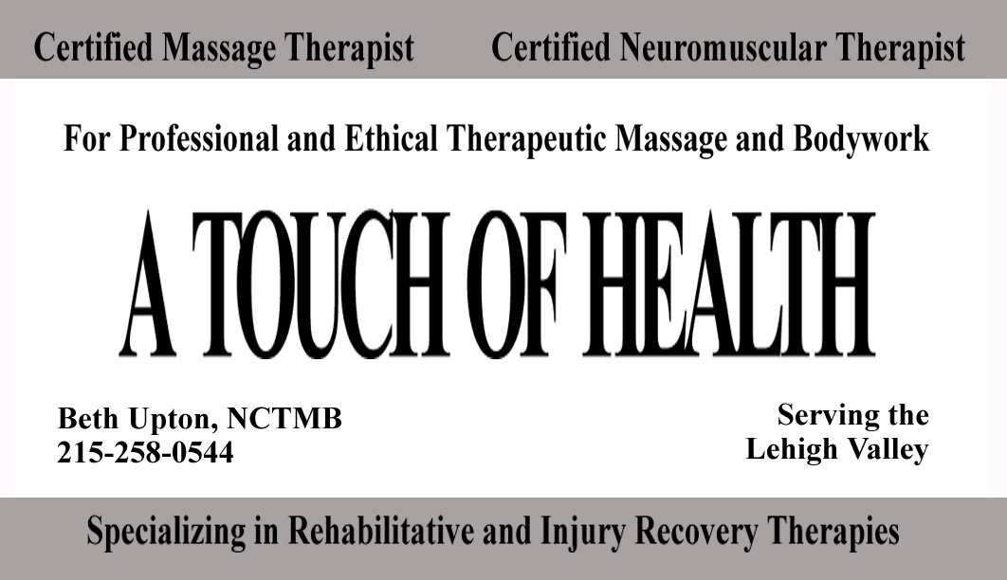

Therapeutic
Massage



Support for the mind, body and spirit

Massage can help with…

Stress
Massage is one of the best known antidotes for stress. Reducing stress gives you more energy, improves your outlook on life, and in the process reduces your likelihood of injury and illness. Massage can also relieve symptoms of conditions that are aggravated by anxiety such as asthma or insomnia.

Painful or tight muscles
Massage can relieve many types of muscle tightness, from a short-term muscle cramp to habitually tight shoulders. Some massage techniques release tension directly by kneading your muscles and their connective tissue coverings (called fascia). Other techniques work less directly, but quite powerfully, by stimulating your nervous system to allow your muscles to relax.

Delayed muscle soreness
After vigorous exercise, a buildup of waste products in your muscles can leave you feeling tired and sore. Massage increases circulation, which removes waste products and brings in nutrients. Massage can help you stay vigorous and active, and lessen recovery times from strenuous workouts.

Prevention of new injuries
Besides releasing tight muscles that restrict joint movements, massage works directly on your joints to improve circulation, stimulate production of natural lubrication, and relieve pain from conditions such as osteoarthritis, as well as increasing pain free range of motion.

Pain or tingling in your limbs
Muscles can become so contracted that they press on nerves in the arms, hands and legs, causing pain, tingling or numbness. If this happens, massage may be able to release muscle spasms in these areas and bring much needed relief. In some cases, the pain or tingling may not be from pressure by a muscle, but pressure from a bone that may have shifted slightly as a result of daily use, or a particular injury. If that is the case, your therapist may refer you to a chiropractor for an adjustment before working on your muscles just to be safe. Massage therapists are not allowed to perform any type of skeletal manipulations.

Secondary pain
Massage can relieve the secondary pain that can outlast its original cause. Some examples of this are headaches from eyestrain, chronic low back aches from an old injury or bad posture, or the protective tensing of healthy muscles around the area of an injury.

Posture
Massage releases restriction in muscles, joints, and the surrounding fascia, freeing your body to return to a more natural posture. Massage can also relieve the contracted muscles and pain caused by abnormal spinal curvatures such as scoliosis.

The effects of forced inactivity
There are many reasons why you may be forced to limit physical activity including injury, surgery, paralysis or even normal aging. When this happens, massage can relieve your aches and pains and improve circulation to your skin and muscles. Even when an immobilized area cannot be massaged directly, the relaxation and increased circulation from a general massage can bring you relief.

How will a massage feel?
Massage on normal tissue is almost always a pleasant sensation. Massage in the area of an injury or chronic pain may at first cause some discomfort, which will usually lessen noticeably in the first few minutes. Your therapist knows ways to minimize pain and will work carefully within what feels right to you. Always tell your therapist if you feel discomfort, so he or she can make adjustments in pressure or technique.

Is Massage always appropriate?
There are some conditions for which massage is not appropriate. Always tell your therapist if you have any medical problems, even a minor one. In addition, your therapist will ask you to fill out a short intake form, which includes a section about your general health. Please note any health issues or medical problems on that form.

What should I expect afterwards?
Massage can be profoundly relaxing, affecting all of your body systems. After a session, most people feel very relaxed; many experience relief from aches and pains that have built up over months of tension or repetitive activity. After the initial period of feeling “slowed down”, people often experience an increased energy that can last for several days.
Sometimes you may not feel dramatic results right away, but will see changes over the following days. You may notice some localized soreness in areas where your therapist did deeper work, this is normal, but it is not normal to experience a new area of pain after a massage session and you should contact your therapist if this happens. It is also a good idea to remember to drink water after a massage session. Because massage increases the circulation to your tissues and removes waste products, your kidneys could use a little help in flushing that out of your body.

