Massage for Sports injuries
An injury to anyone who loves to be active Is more than just pain and frustration. With specific fitness goals in mind, injuries can mean setbacks, missed sessions, and you can even lose ground during the healing process. Massage can help.
A variety of massage techniques can help with injuries such as tendonitis, muscle strain, and ligament sprains. Because massage increases circulation, it can also reduce swelling and increase the supply of nutrients needed for healing.
In addition, your body often repairs injuries with scar tissue consisting of tightly matted collagen fibers. These fibers can restrict normal tissue movement causing limited or painful range of motion. Appropriate massage techniques can limit scar tissue formation in new injuries and can reduce, or make more pliable, the scar tissue around old injuries. Your muscles and joints will move more freely and with less pain.
You may experience some discomfort at first with massage in the area of an injury or chronic pain, but the sensation should lessen after a few minutes. You should always tell your massage therapist if your session is uncomfortable in anyway. She or he can work within your comfort level by using less pressure or changing techniques.

Your Massage Therapist
Massage therapists have extensive training in a wide variety of massage techniques and modalities, anatomy and physiology, and knowledge about when massage is and is not appropriate for a person. In addition, therapists with training in sports massage understand the unique demands that each different sport or training program places on the body. Most professional therapists are certified by schools and/or the National Certification Board. Your therapist will gladly explain his or her specialized education, experience and certification.

This brochure was provided to you by:
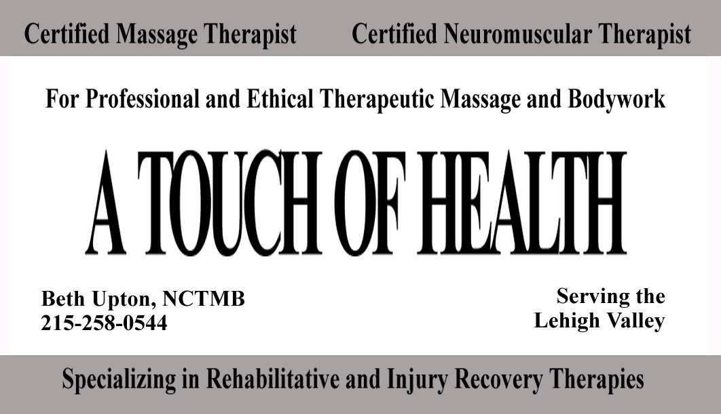

With an office conveniently located in the GOLD’S GYM Bethlehem Facility
Massage and Fitness


Support for
an active
life style

Massage can help with…

Stress
Massage is one of the best known antidotes for stress. Reducing stress gives you more energy, improves your outlook on life, and in the process reduces your likelihood of injury and illness. Massage can also relieve symptoms of conditions that are aggravated by anxiety such as asthma or insomnia.

Painful or tight muscles
Massage can relieve many types of muscle tightness, from a short-term muscle cramp to habitually tight shoulders. Some massage techniques release tension directly by kneading your muscles and their connective tissue coverings (called fascia). Other techniques work less directly, but quite powerfully, by stimulating your nervous system to allow your muscles to relax.

Delayed muscle soreness
After vigorous exercise, a buildup of waste products in your muscles can leave you feeling tired and sore. Massage increases circulation, which removes waste products and brings in nutrients. Massage can help you stay vigorous and active, and lessen recovery times from strenuous workouts.

Prevention of new injuries
Besides releasing tight muscles that restrict joint movements, massage works directly on your joints to improve circulation, stimulate production of natural lubrication, and relieve pain from conditions such as osteoarthritis, as well as increasing pain free range of motion.

Pain or tingling in your limbs
Muscles can become so contracted that they press on nerves in the arms, hands and legs, causing pain, tingling or numbness. If this happens, massage may be able to release muscle spasms in these areas and bring much needed relief. In some cases, the pain or tingling may not be from pressure by a muscle, but pressure from a bone that may have shifted slightly as a result of daily use, or a particular injury. If that is the case, your therapist may refer you to a chiropractor for an adjustment before working on your muscles just to be safe. Massage therapists are not allowed to perform any type of skeletal manipulations.

Secondary pain
Massage can relieve the secondary pain that can outlast its original cause. Some examples of this are headaches from eyestrain, chronic low back aches from an old injury or bad posture, or the protective tensing of healthy muscles around the area of an injury.

Posture
Massage releases restriction in muscles, joints, and the surrounding fascia, freeing your body to return to a more natural posture. Massage can also relieve the contracted muscles and pain caused by abnormal spinal curvatures such as scoliosis.

The effects of forced inactivity
There are many reasons why you may be forced to limit physical activity including injury, surgery, paralysis or even normal aging. When this happens, massage can relieve your aches and pains and improve circulation to your skin and muscles. Even when an immobilized area cannot be massaged directly, the relaxation and increased circulation from a general massage can bring you relief.

How will a massage feel?
Massage on normal tissue is almost always a pleasant sensation. Massage in the area of an injury or chronic pain may at first cause some discomfort, which will usually lessen noticeably in the first few minutes. Your therapist knows ways to minimize pain and will work carefully within what feels right to you. Always tell your therapist if you feel discomfort, so he or she can make adjustments in pressure or technique.

Is Massage always appropriate?
There are some conditions for which massage is not appropriate. Always tell your therapist if you have any medical problems, even a minor one. In addition, your therapist will ask you to fill out a short intake form which includes a section about your general health. Please note any health issues or medical problems on that form.

What should I expect afterwards?
Massage can be profoundly relaxing, affecting all of your body systems. After a session, most people feel very relaxed, many experience relief from aches and pains that have built up over months of tension or repetitive activity. After the initial period of feeling “slowed down”, people often experience an increased energy that can last for several days.
Sometimes you may not feel dramatic results right away, but will see changes over the following days. You may notice some localized soreness in areas where your therapist did deeper work, this is normal, but it is not normal to experience a new area of pain after a massage session and you should contact your therapist if this happens. It is also a good idea to remember to drink water after a massage session. Because massage increases the circulation to your tissues and removes waste products, your kidneys could use a little help in flushing that out of your body.

